Trevor Shortlidge
CIS17b

Shopping Cart – Personal Project

To start this application please start with Access.php

Description:
This program simulates a shopping cart. First you Register/Login, if your login has failed with the database it will prompt you to relog in. If your login is successful with the database it saves your session with cookies and local storage. It then will redirect you to another page(the store) to pick and choose items to go in your cart which also saves into cookies and local storage. When you are finished selecting your items. Click on cart and it will redirect you to the checkout page where you can add/delete items from the cart which will update your cookie/local storage. After you are finished you check out and you're done. You will get a receipt when finished.

Rules:
-User must register an account(deals with regular expressions)
-User must then login with regular expressions to access the site.
-Select items to put in cart
-Cart handles all the items for removing adding and clearing.
-Checkout finalizes your cart and prints out a receipt.
-Log out clears cookies/localstorage/session
-If needed to edit/view users, register admin or login
-Admin page -> views/edits/deletes users
Code:
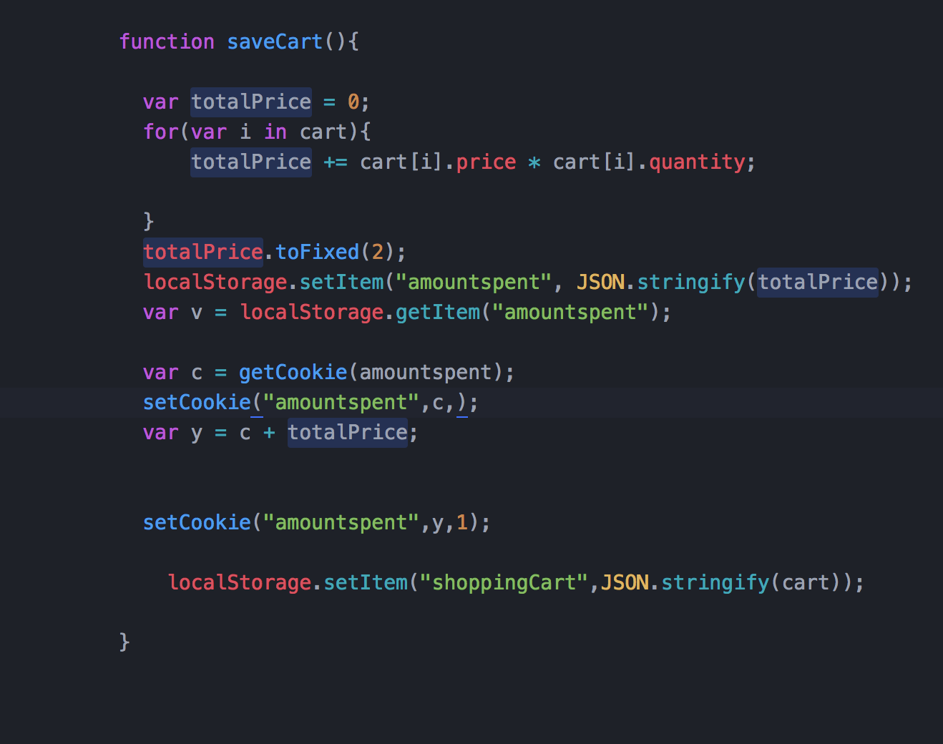

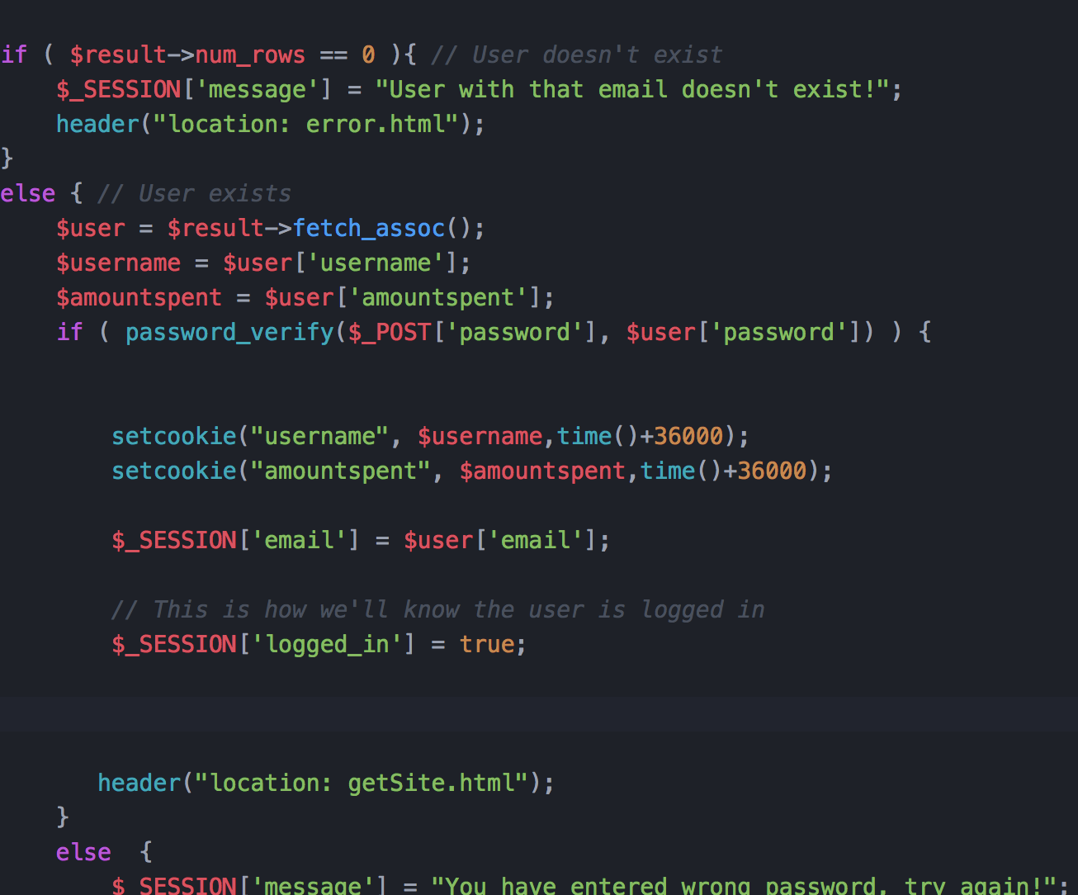

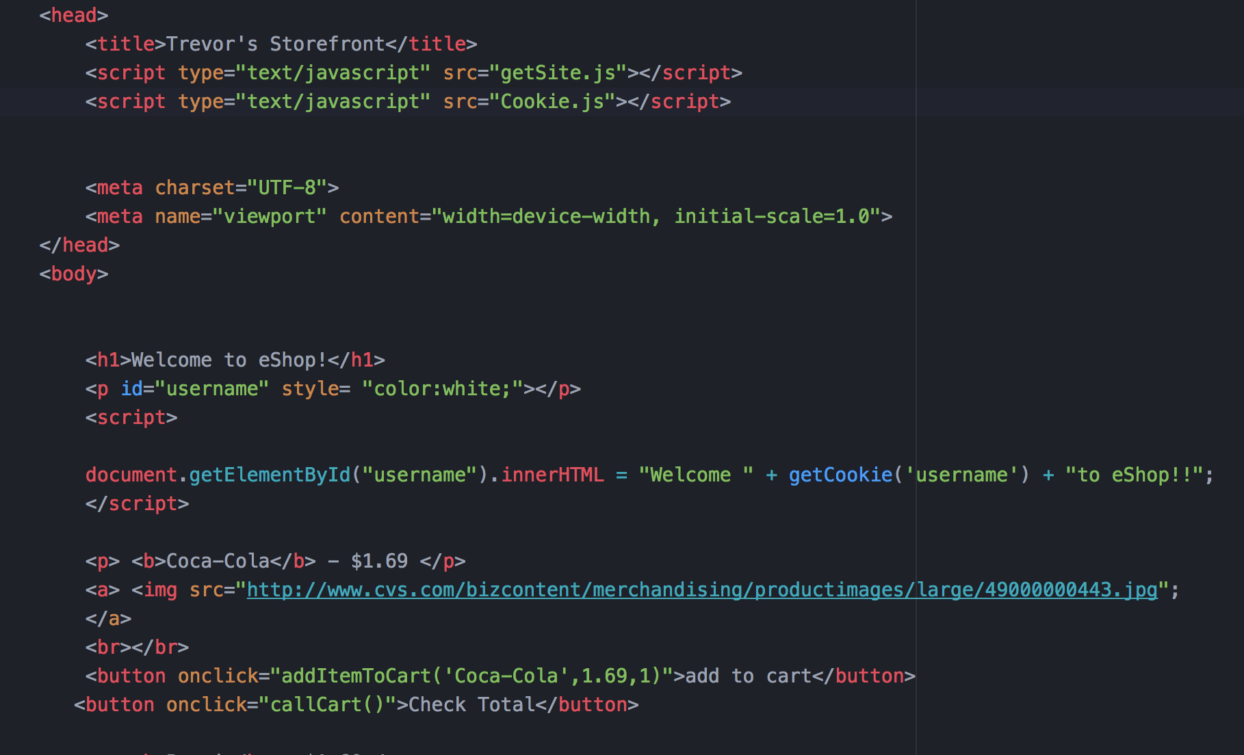

ScreenShots:
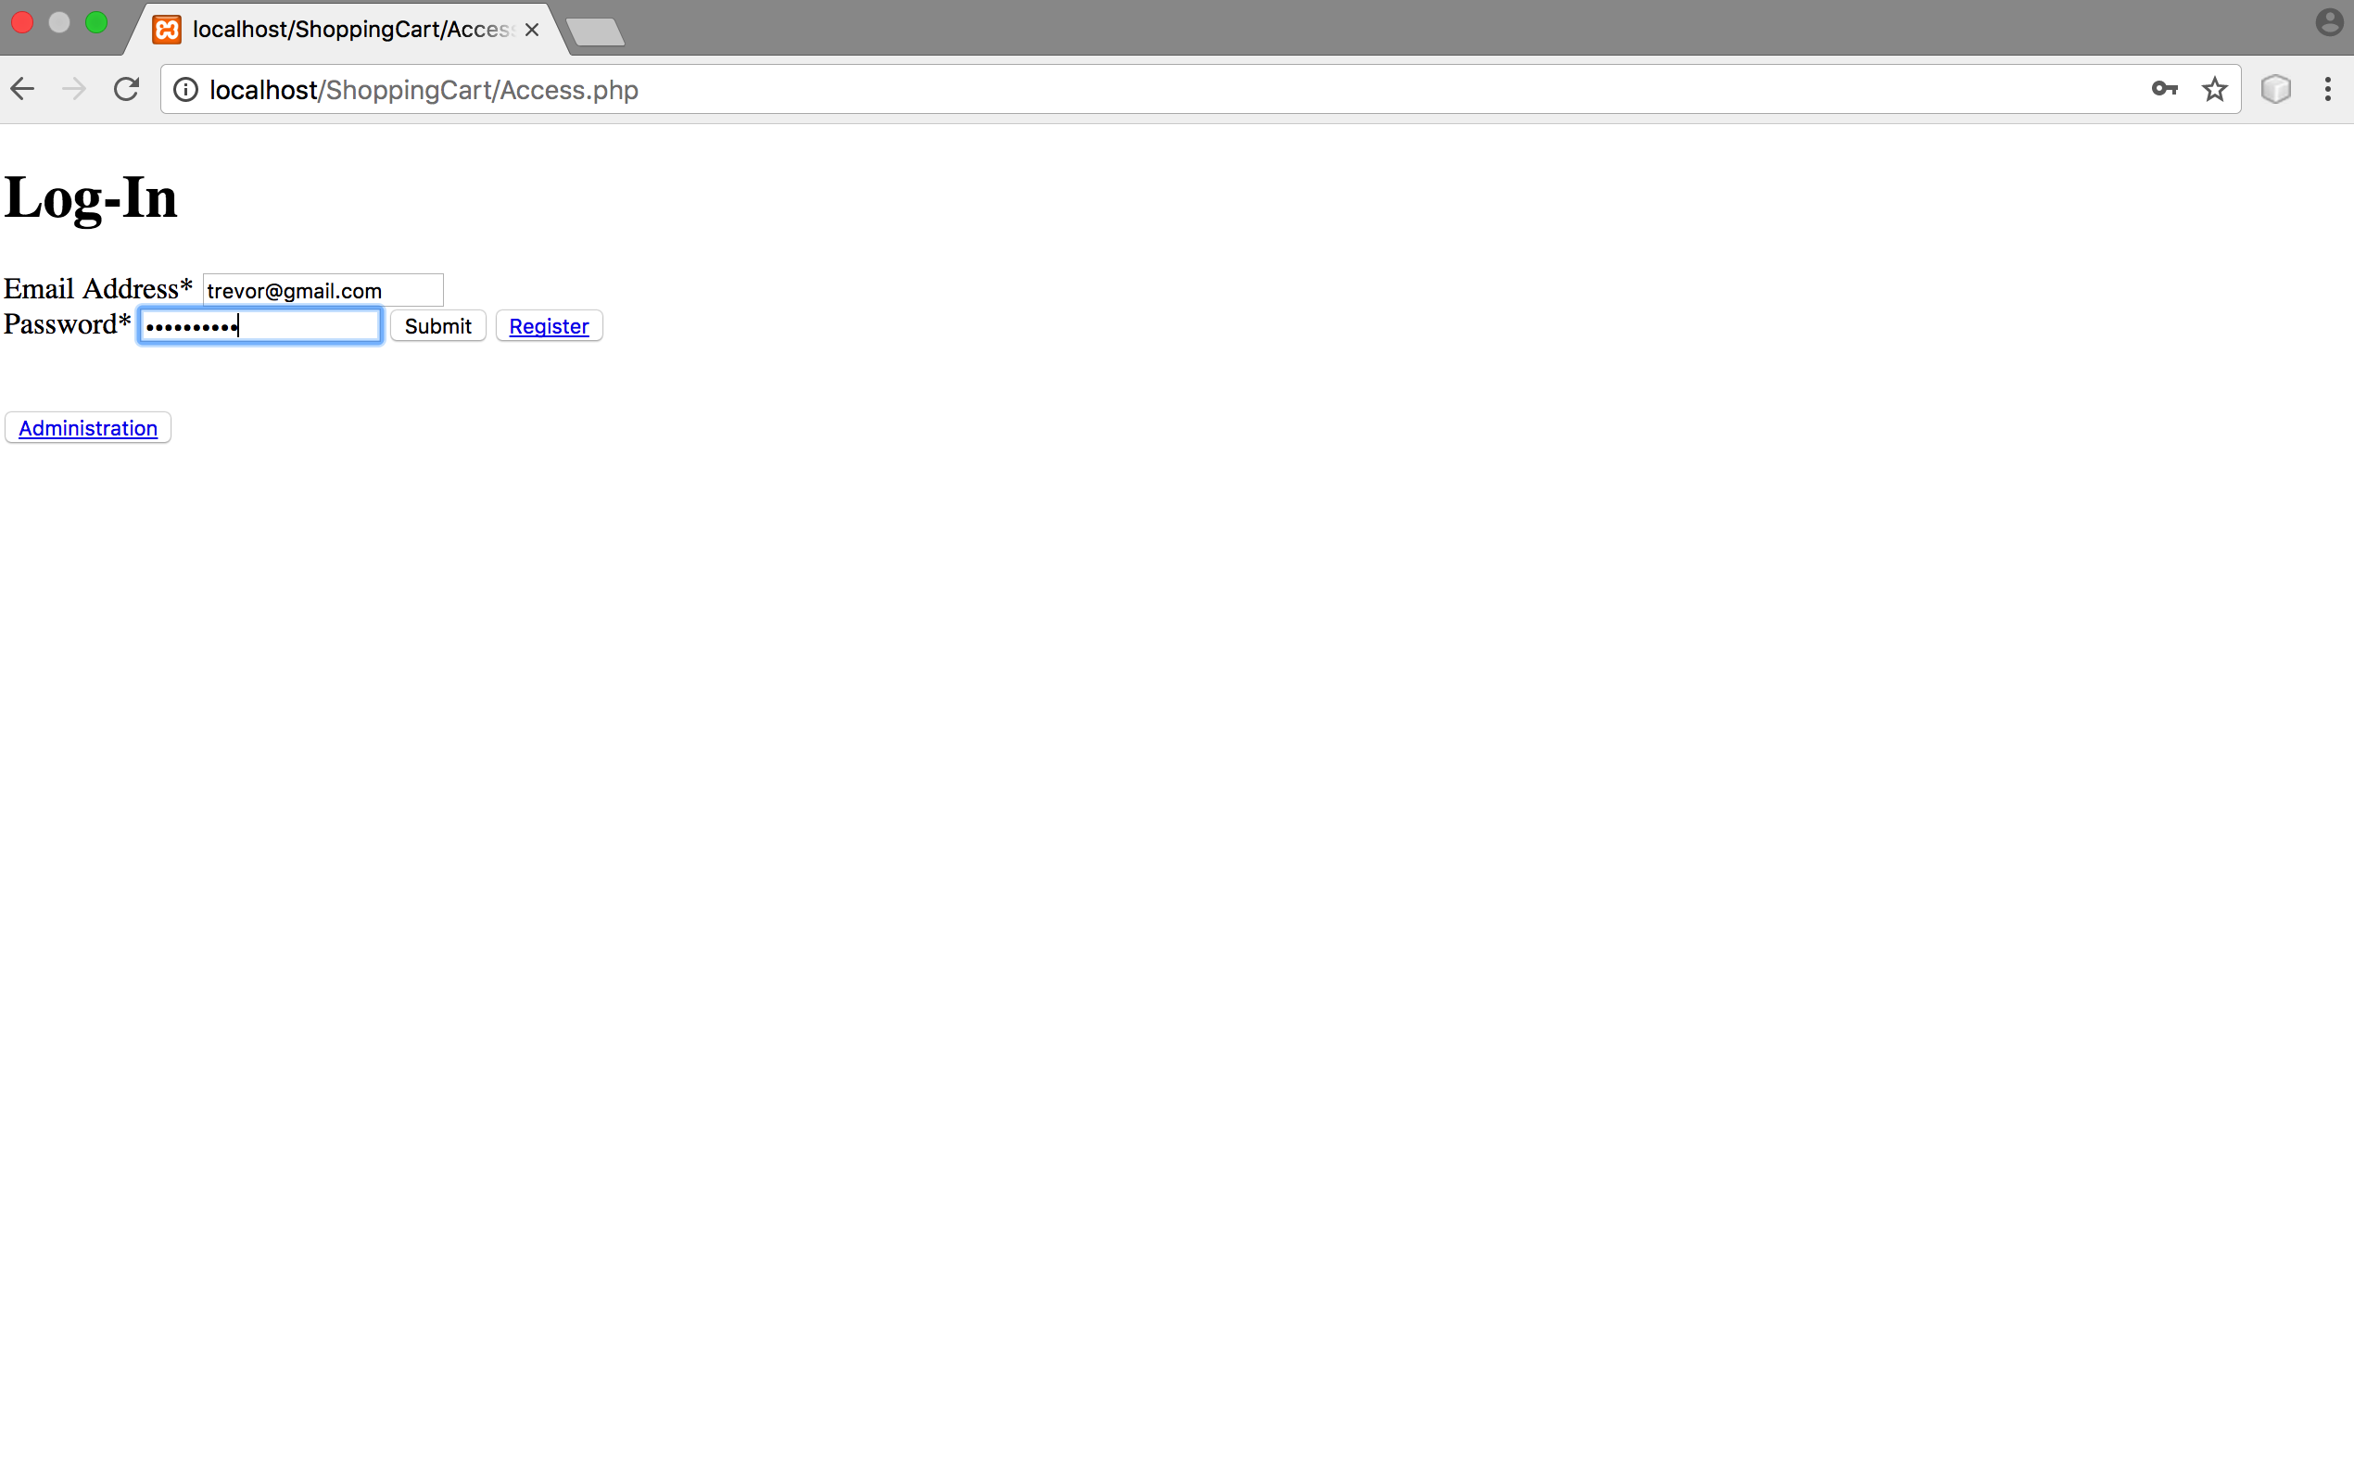
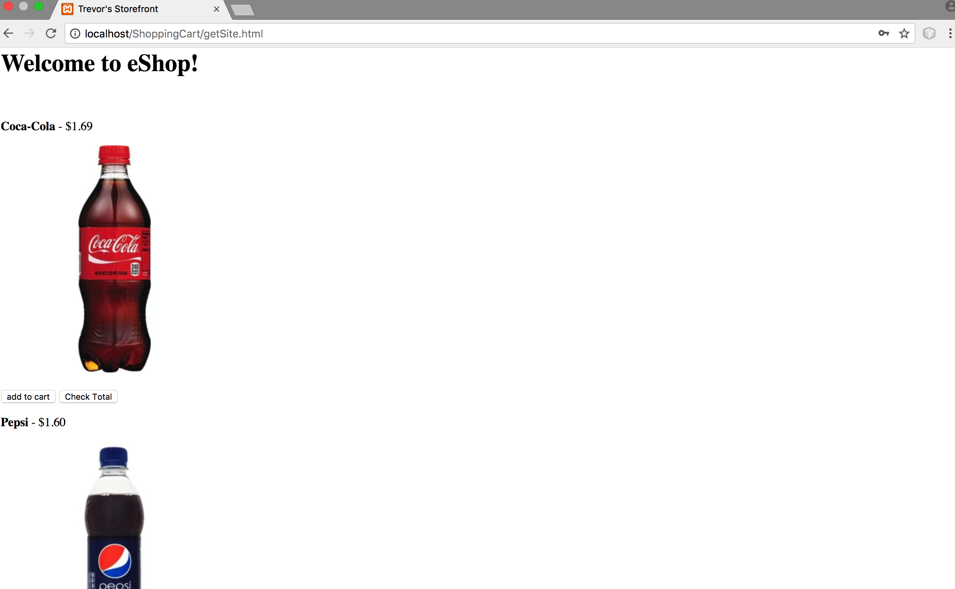
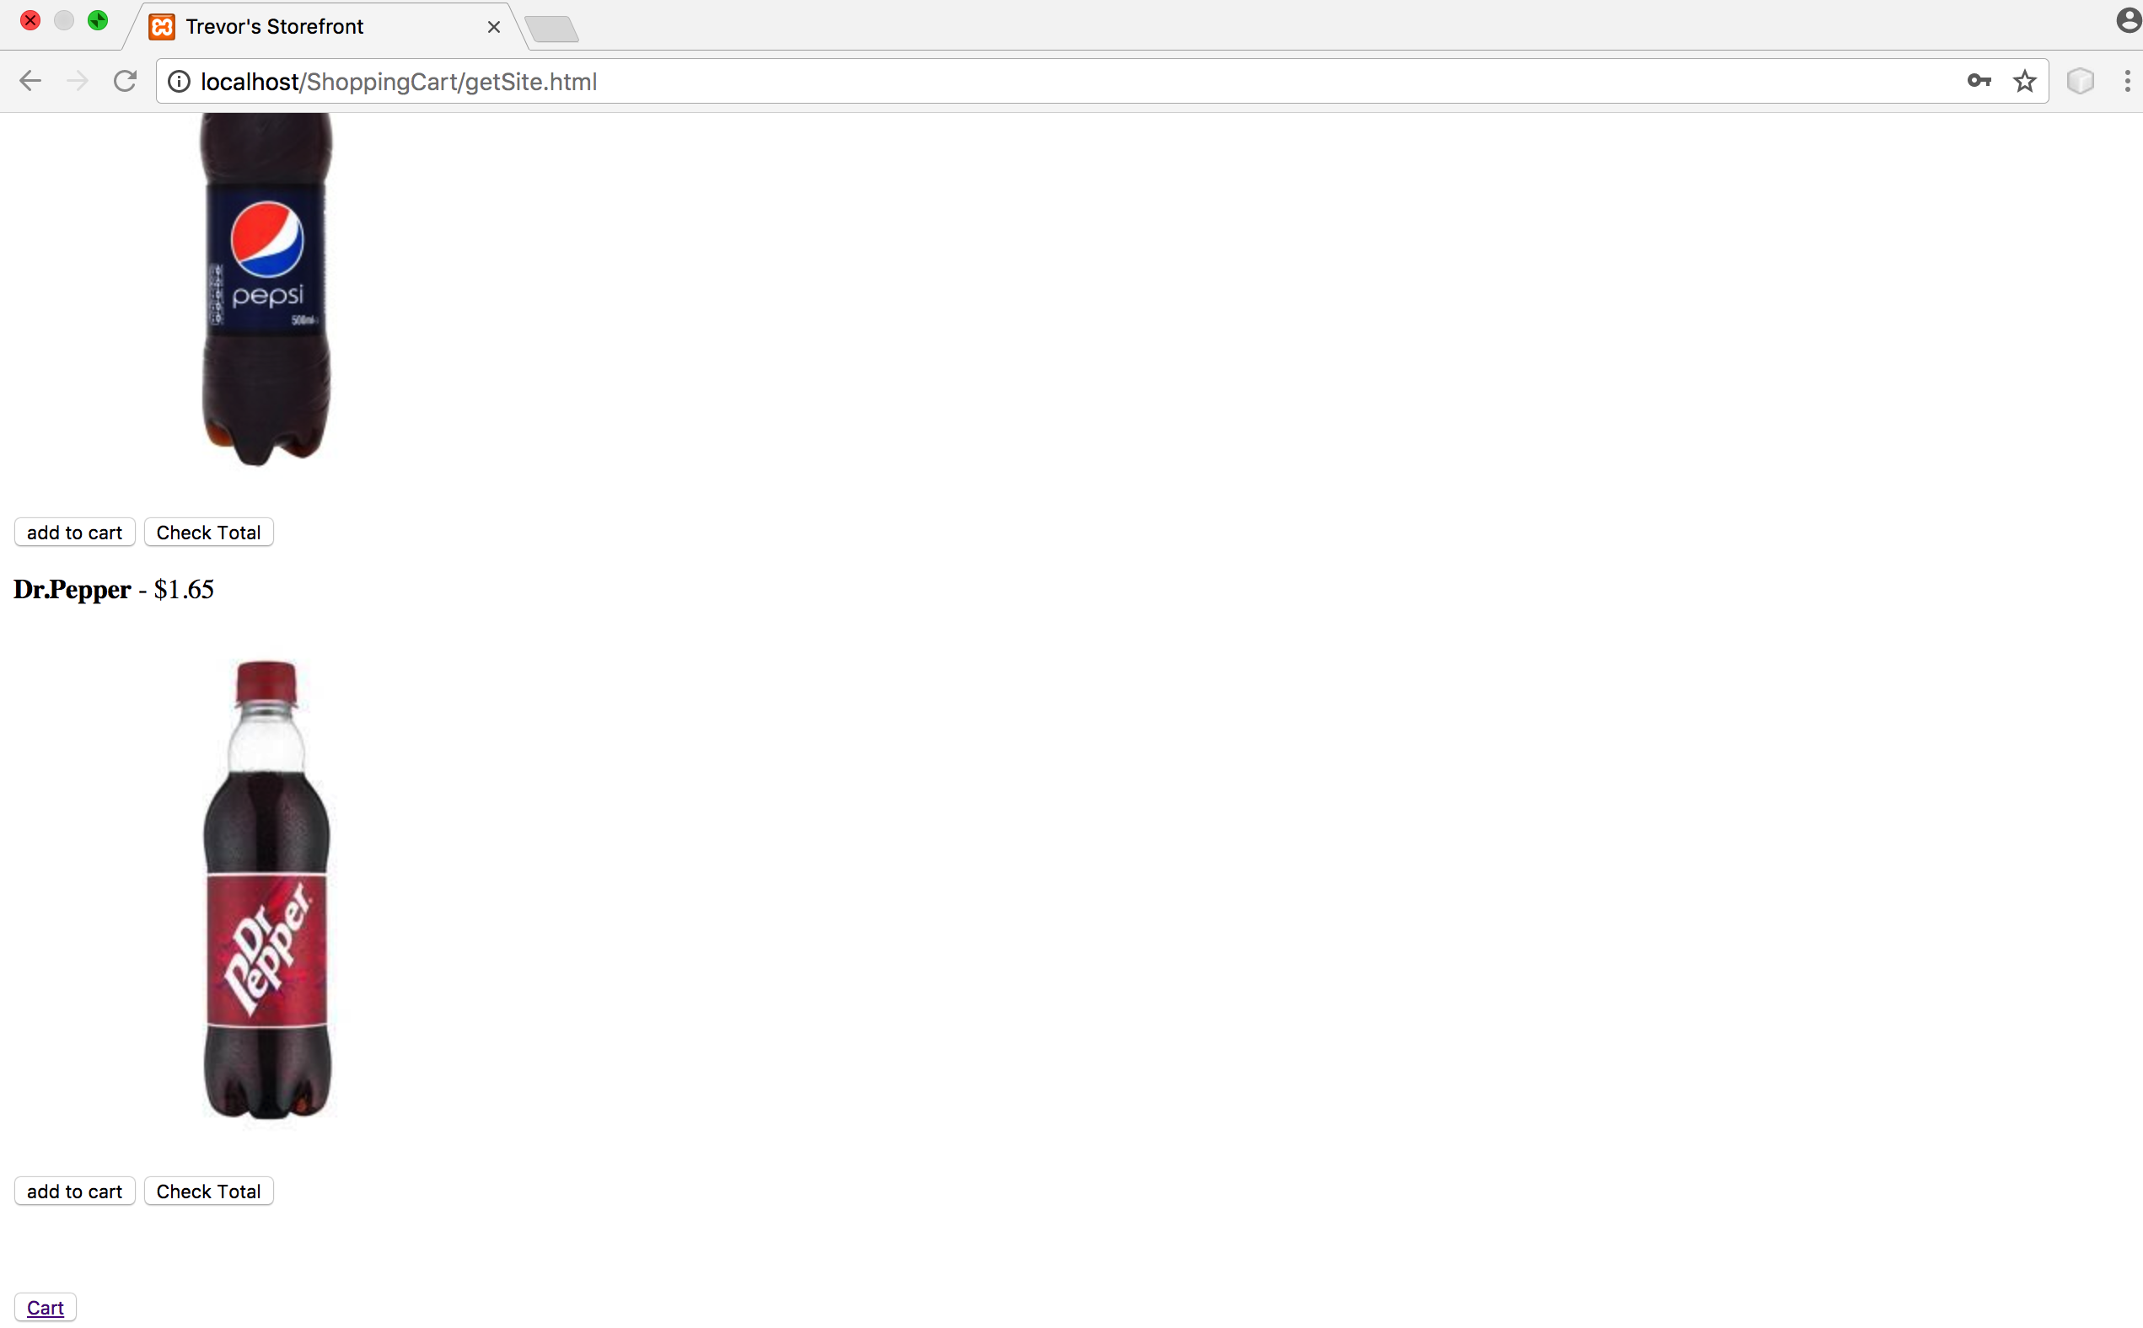
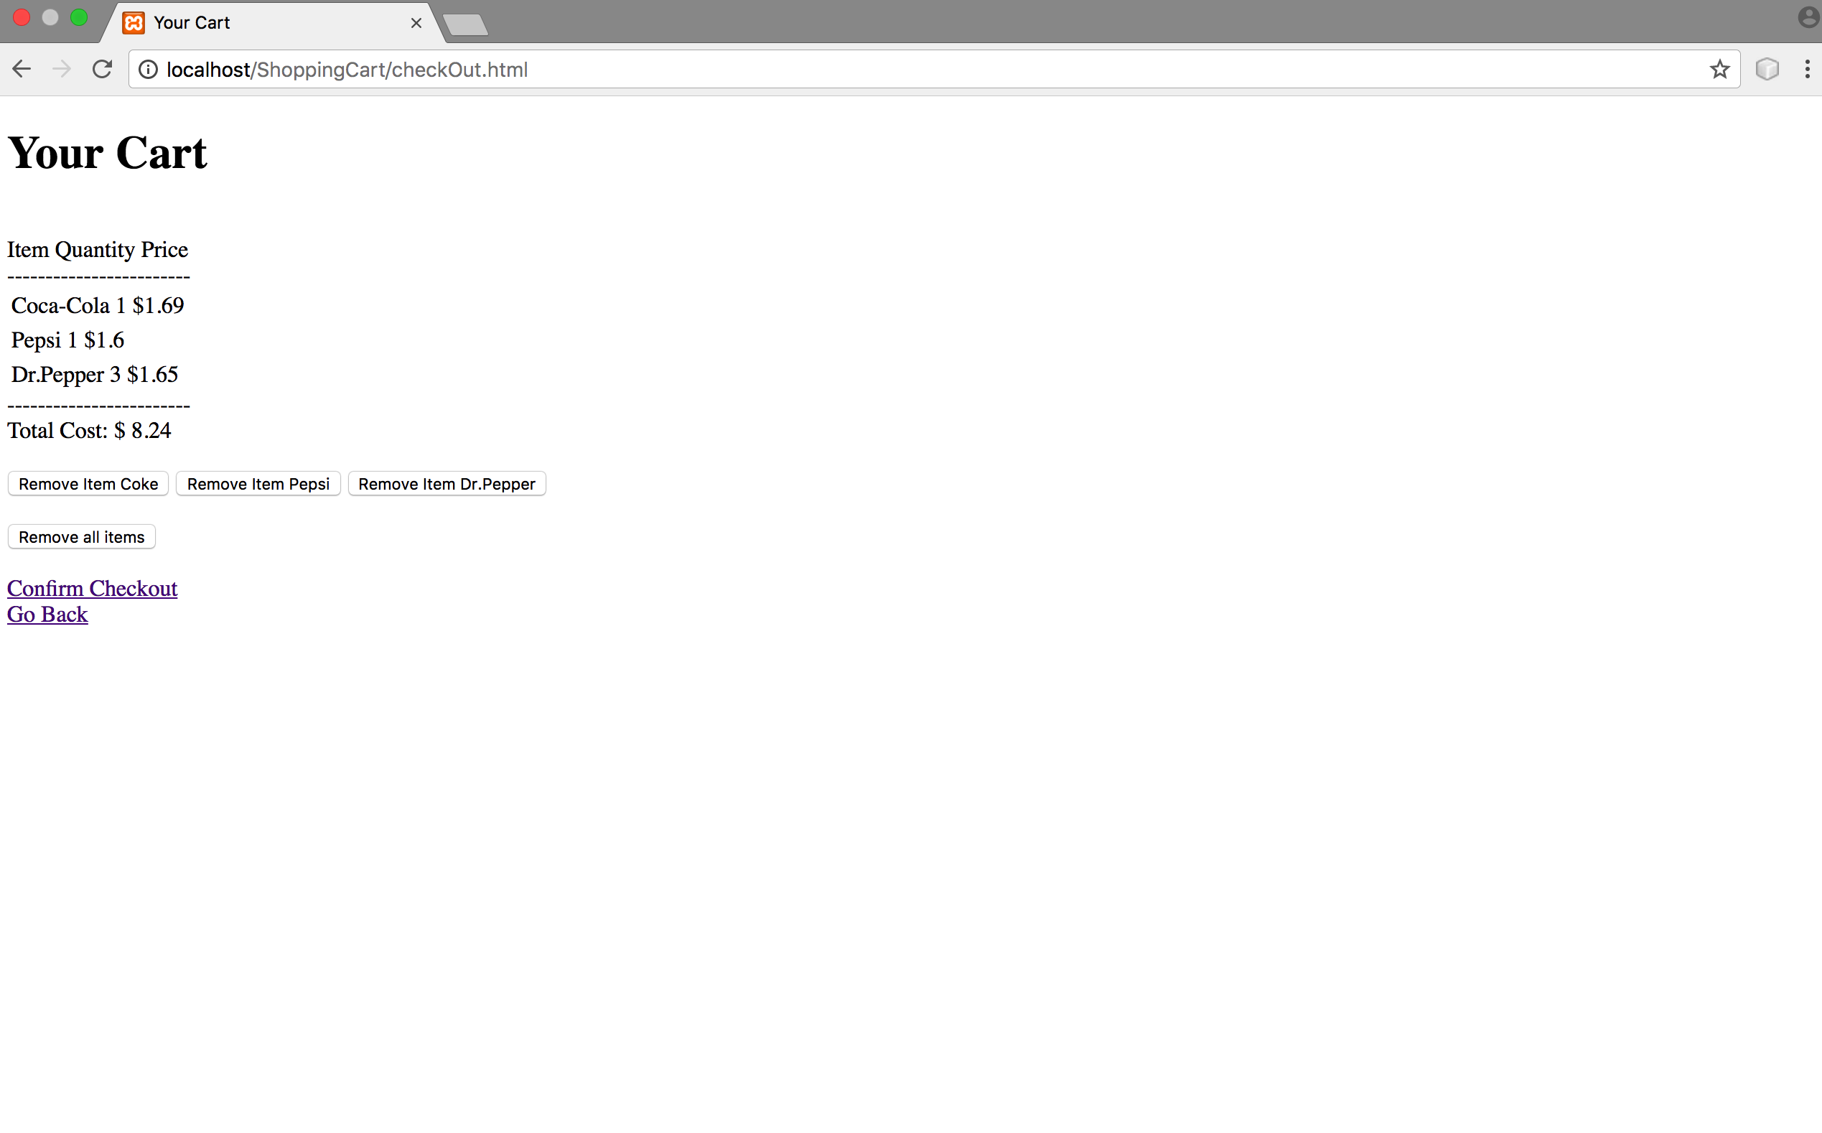

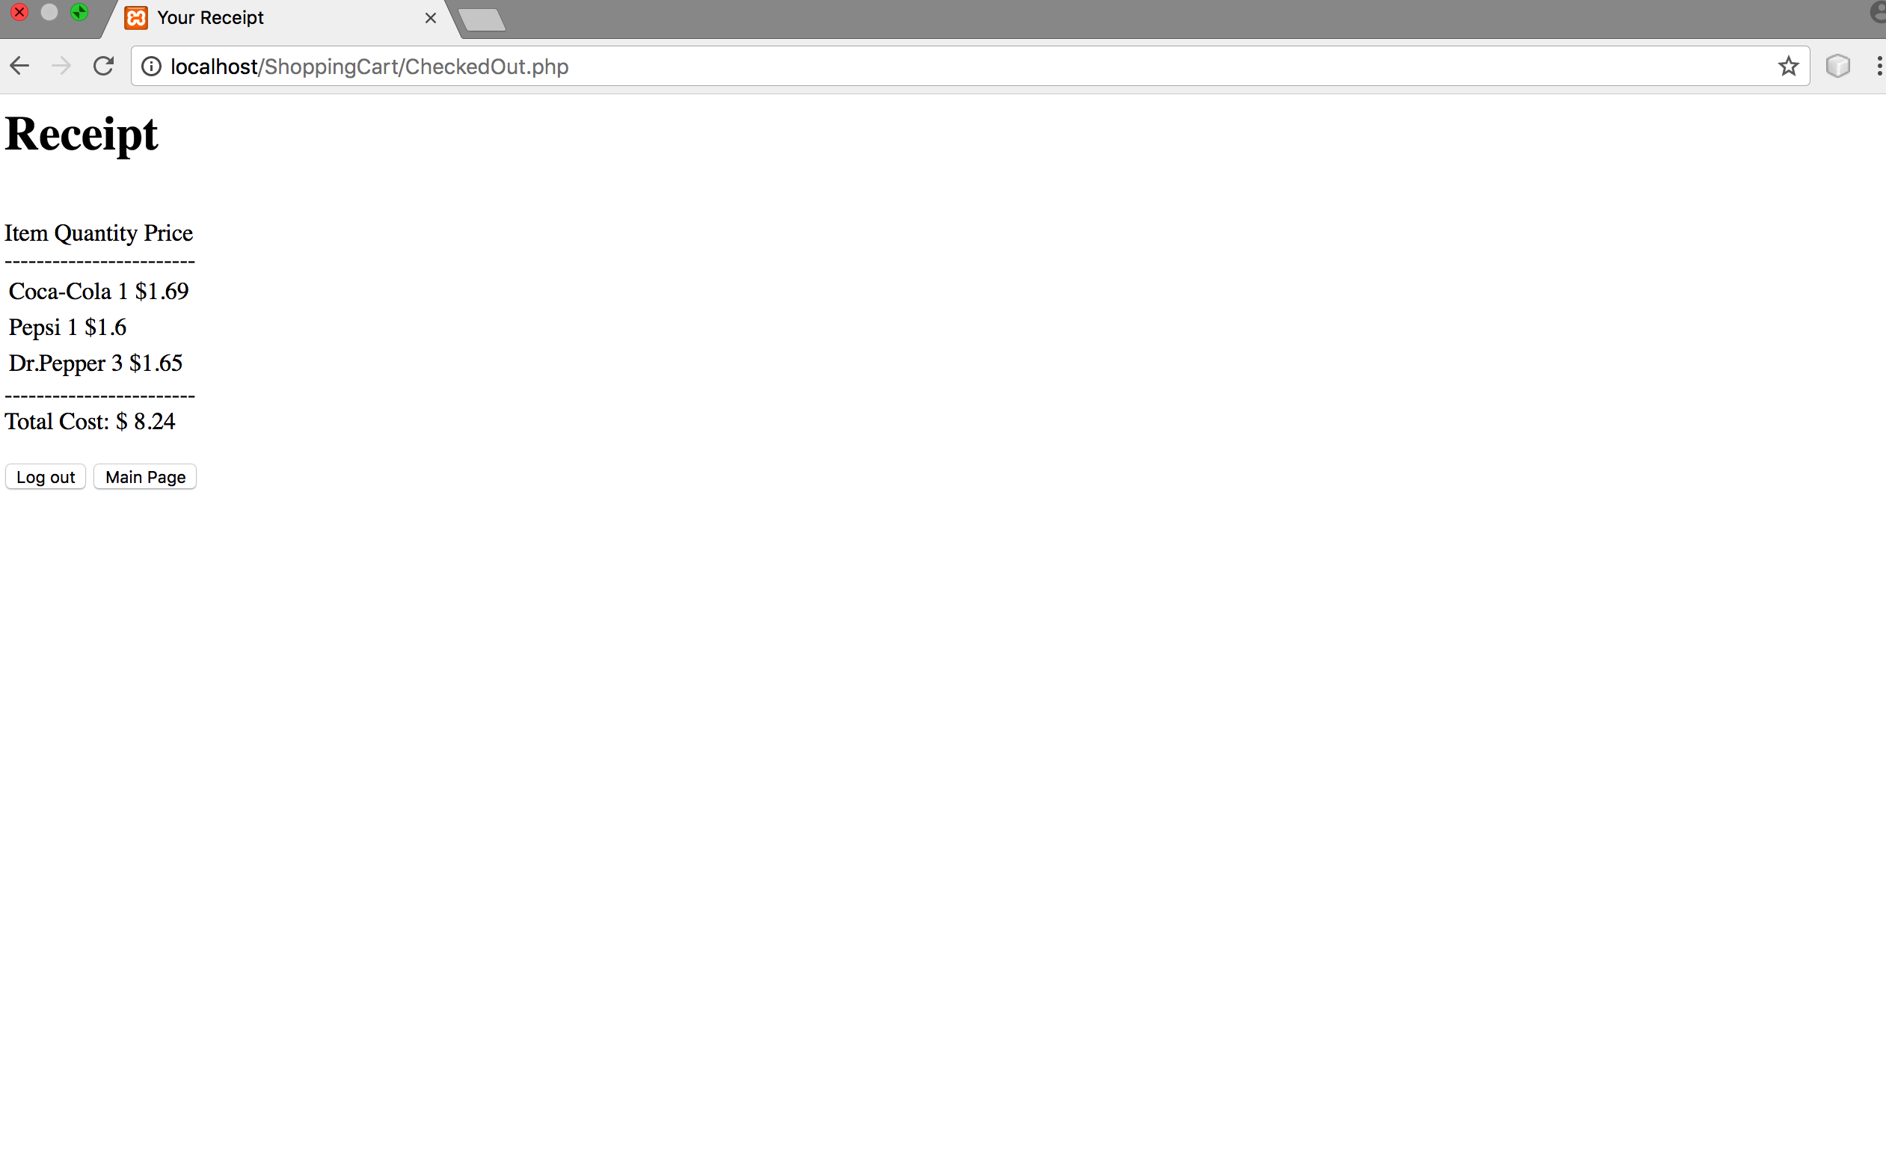
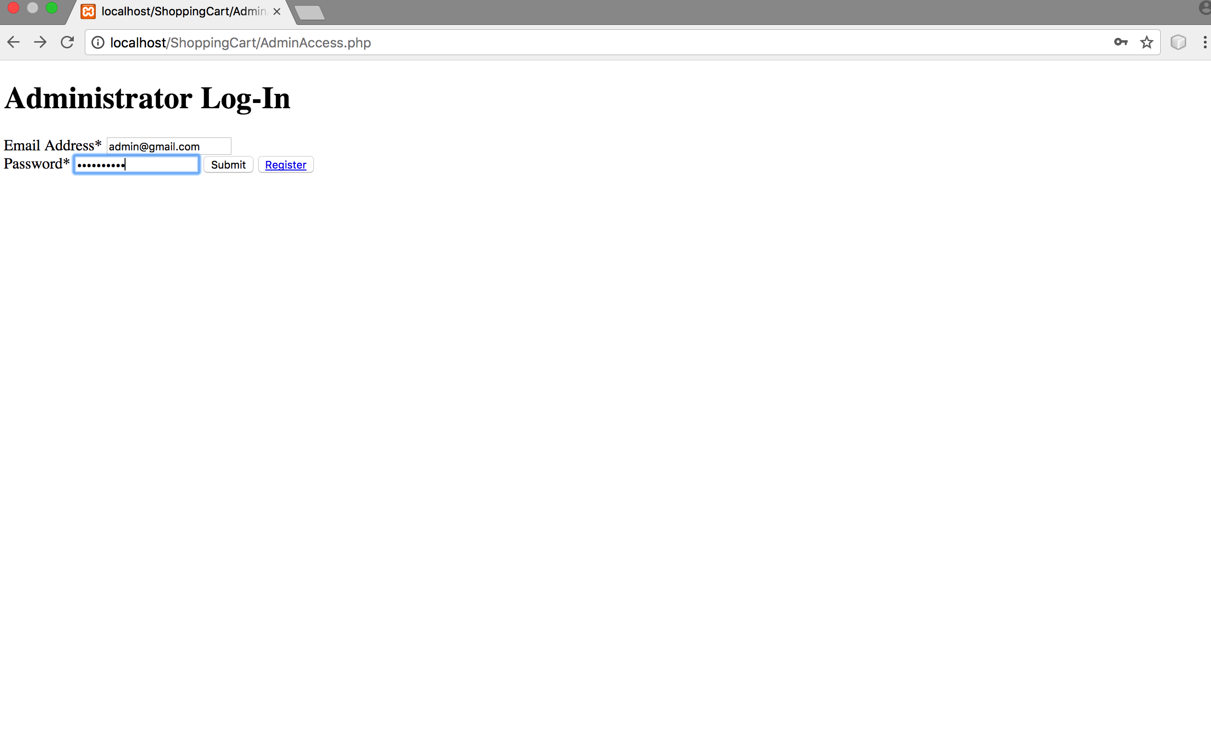
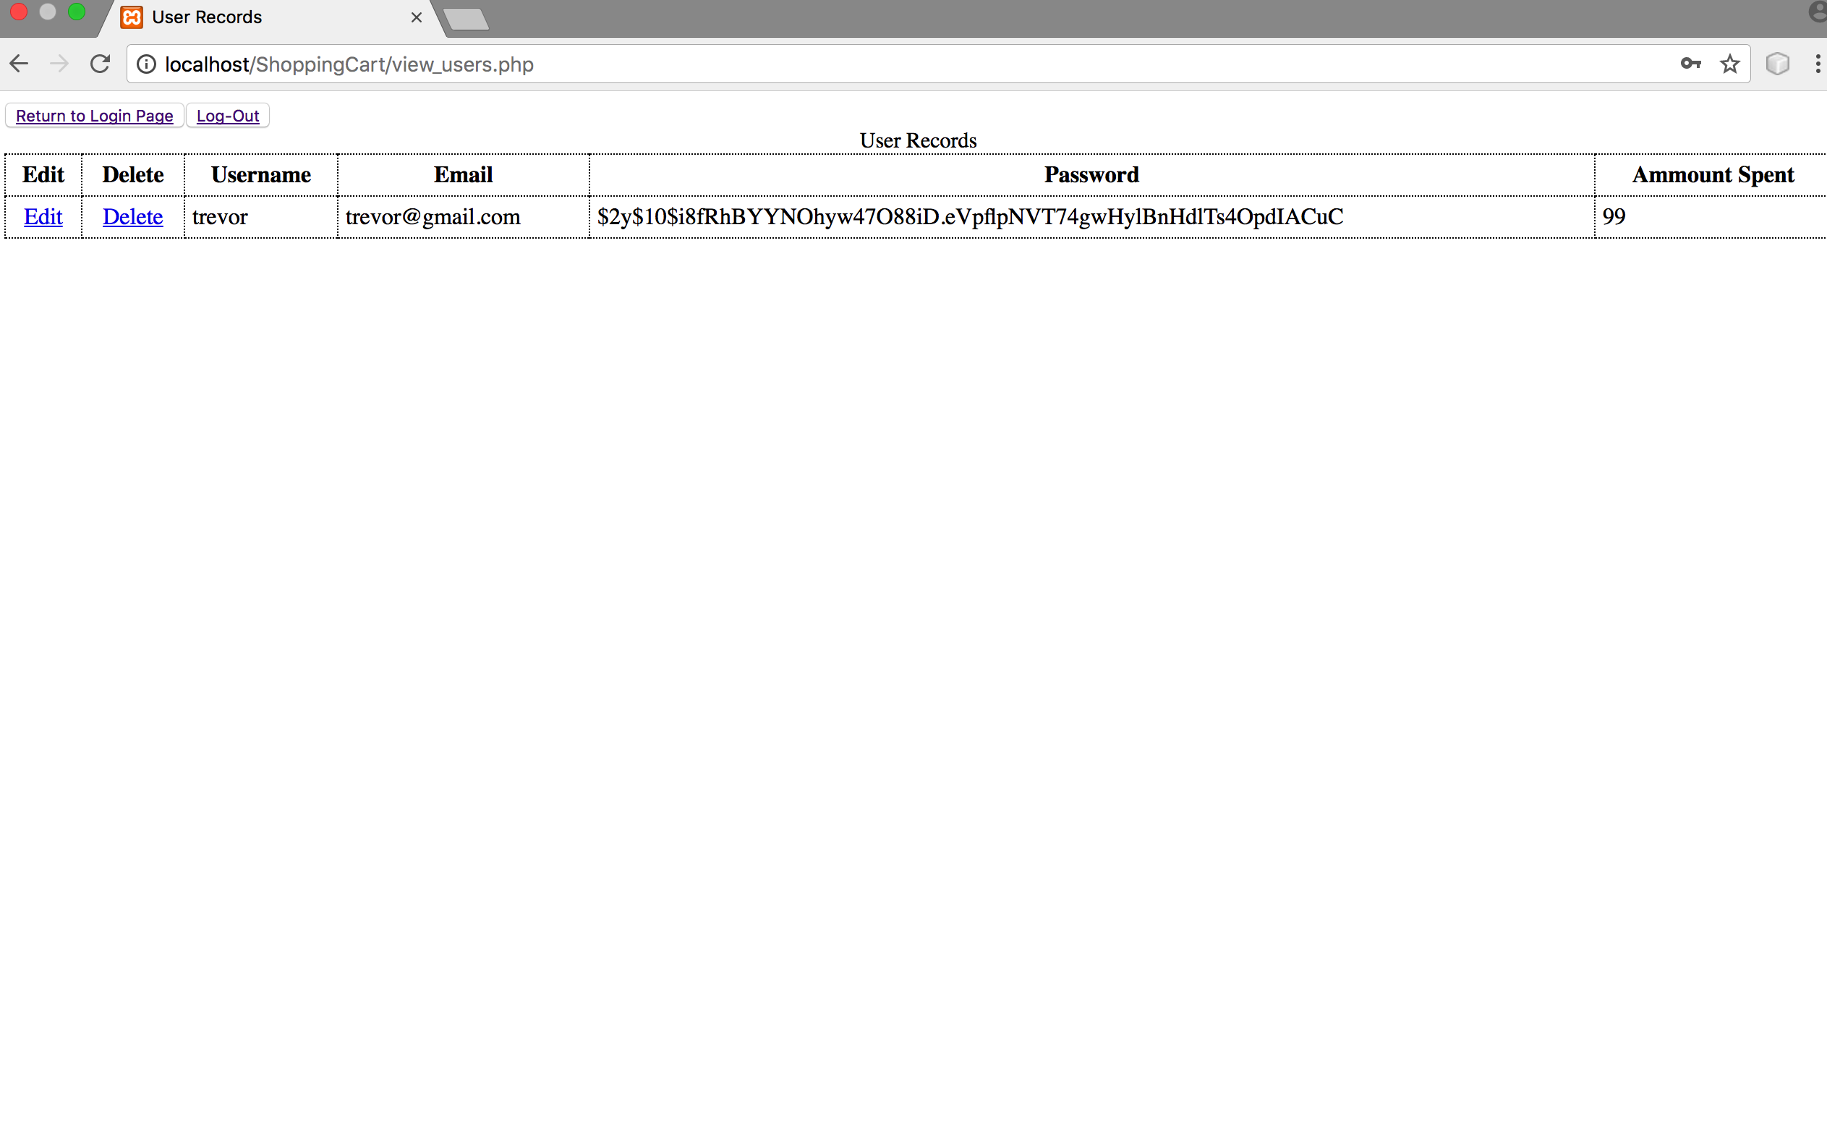

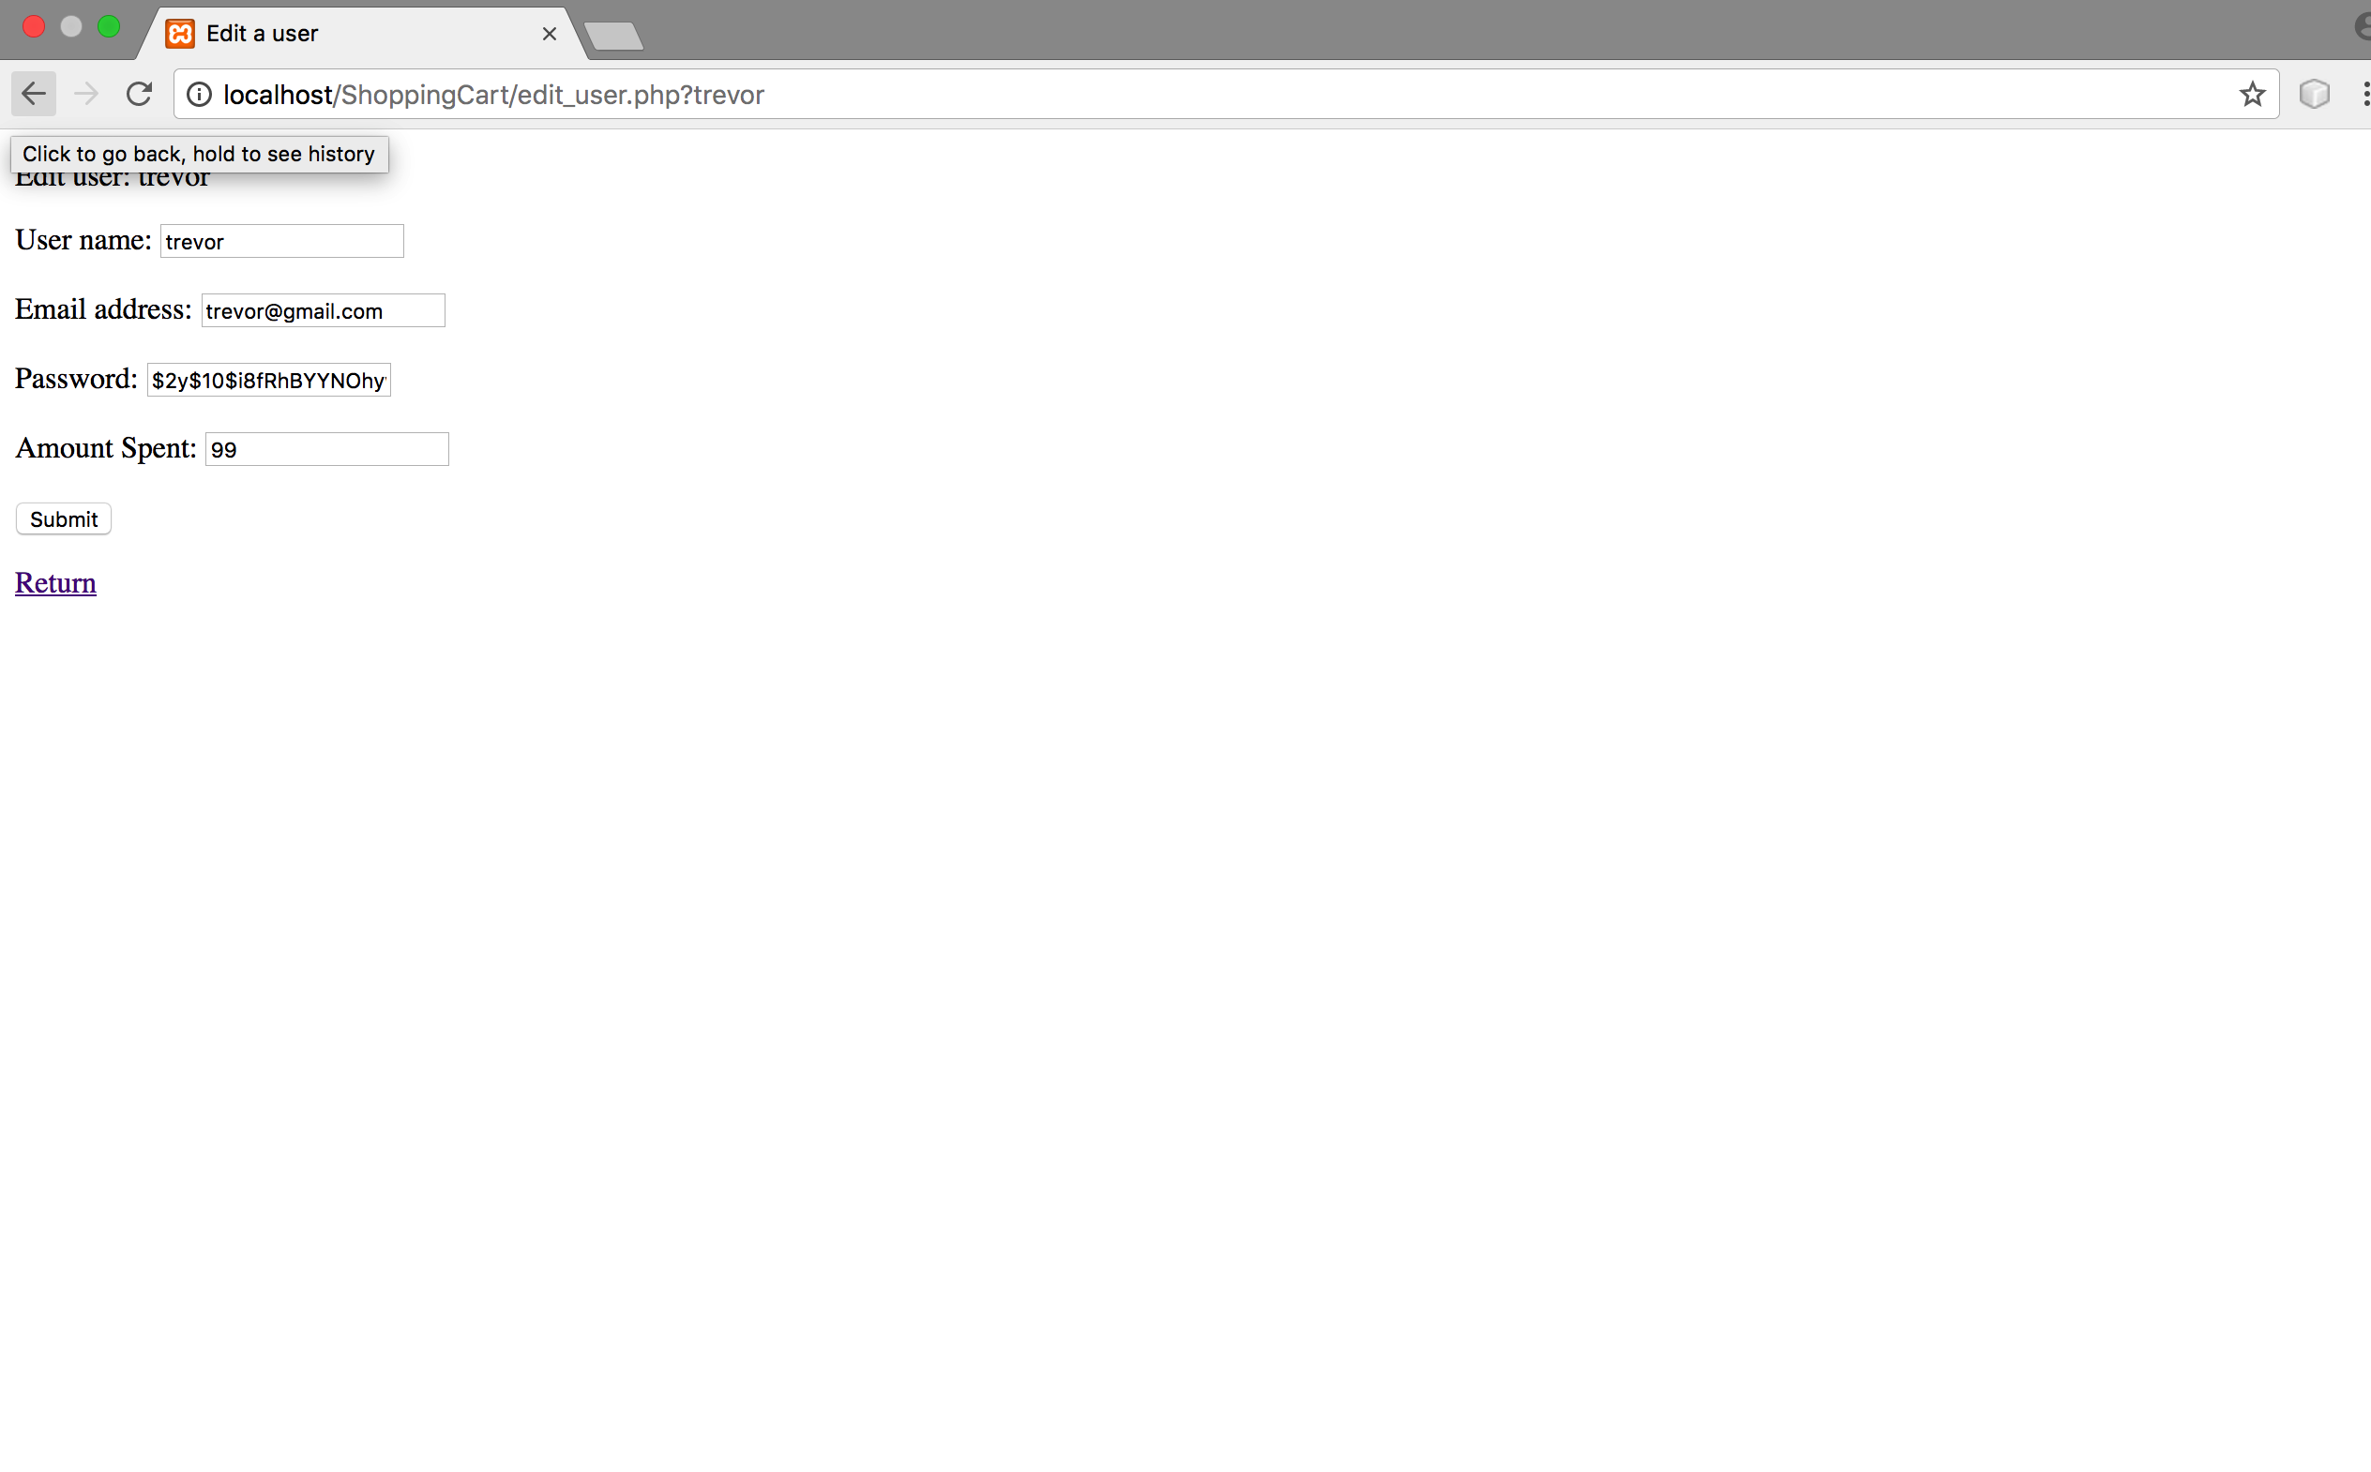
Github link: https://github.com/tshortlidge/ShortlidgeTrevor_CIS_CSC_17b_Fall2017/tree/master/Projects/Shopping%20Cart%20

